**Week-2: (Module 4)**

**TDD using JUnit5 and Mockito**

**Exercise 1: Setting Up JUnit**

**Calculator.java**

public class Calculator {  
 public int add(int a, int b){  
 return a+b;  
 }  
 public int subtract(int a, int b){  
 return a-b;  
 }  
 public int multiply(int a, int b){  
 return a*b;  
 }  
}

**CalculatorTest.java**

import org.junit.Test;  
import org.junit.experimental.categories.Categories;  
  
import static org.junit.Assert.*assertEquals*;  
public class CalculatorTest {  
 @Test  
 public void testAdd(){  
 Calculator cal=new Calculator();  
 int result=cal.add(2,3);  
 *assertEquals*(5,result);  
 }  
 @Test  
 public void testsubtract(){  
 Calculator cal=new Calculator();  
 int result=cal.subtract(5,3);  
 *assertEquals*(2,result);  
 }  
 @Test  
 public void testmultiply(){  
 Calculator cal=new Calculator();  
 int result=cal.multiply(3,2);  
 *assertEquals*(6,result);  
 }  
}

Output:

Scenerio 1 : Passed Test Case

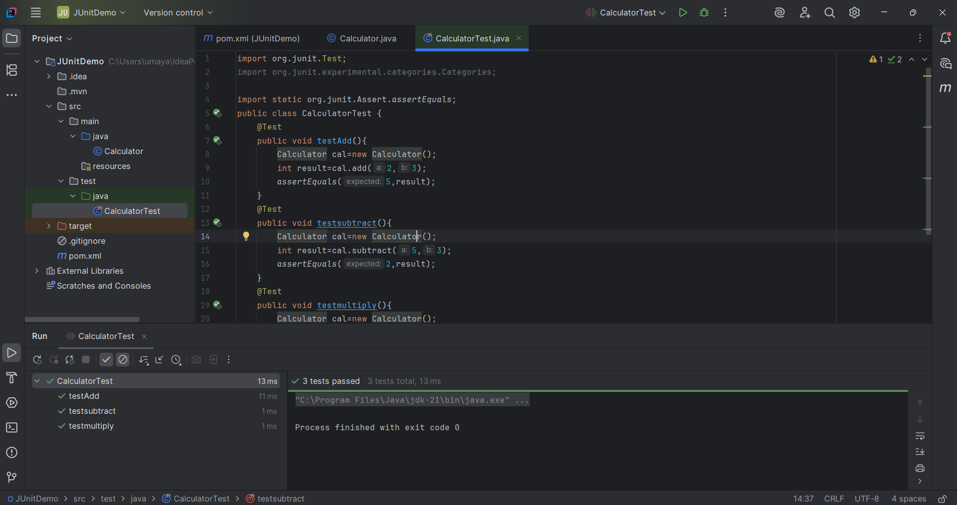

Scenerio 2: Failed Test Case

